SECTION CC

TIMING OPERATIONS

CONTENTS

Chapter

Timing Engine Camshaft .. .. .. .. .. .. .. 1

Timing Fuel Pump Camboxes .. .. .. .. .. .. 2

Checking and Adjusting Fuel Pump Timing .. .. .. .. 3

Special Tools.. .. .. .. .. .. .. .. .. 4

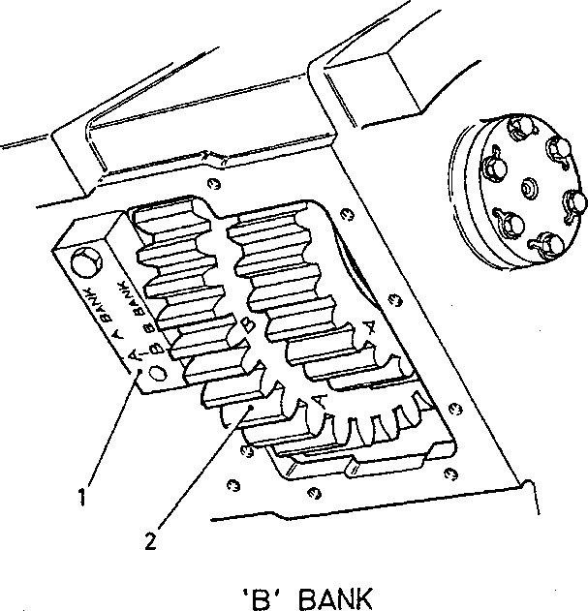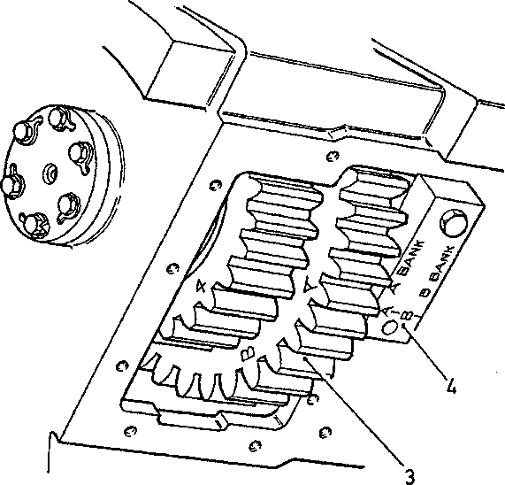

10

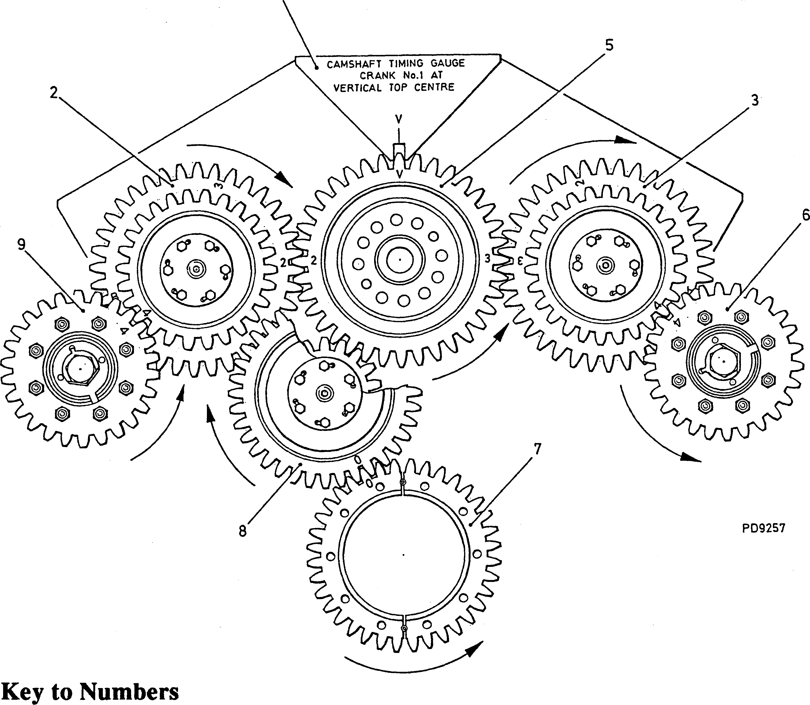

|  |  |  |  |
| --- | --- | --- | --- |
| 1. | Timing gauge, on 'B' bank | 6. | Pump camshaft, 'A' bank |
| 2. | Fuel pump idler, 'B' bank | 7. | Crankshaft gearwheel |
| 3. | Fuel pump idler, 'A' bank | 8. | Main idler gear, |
| 4. | Timing gauge, on 'A' bank | 9. | Pump camshaft, 'B' bank |
| 5. | Camshaft gearwheel | 10. | Camshaft timing gauge |

Fig CC.l Drive-end gear train showing timing marks

CHAPTER 1

TIMING ENGINE CAMSHAFT

NOTES (1) Engine camshaft (5)(Fig CC.l) is driven from crankshaft gearwheel (7) via main idler gear (8). Fuel pump camshafts (9) and

1. are driven from the engine camshaft via fuel pump idler gears (2) and (3). Both fuel pump idler gear assemblies are identical in appearance and carry the same timing references, but different marks are used according to bank.
2. The engine camshaft must be timed with Nos 1 and 8 crankpins at Vertical Top Centre (VTC); this can be found by aligning the mark on the drive-end flange of the crankshaft with the 'VTC' mark on the drive-end cover and crankshaft. If access to the drive-end cover and crankshaft is not possible due to the driven unit, 'VTC' can be found using the dummy injector shown in Fig CCA.
3. Due to the limited space in the gear compartment of the crankcase, it is suggested that the meshing tooth and the two teeth with which it will mesh are marked with white or yellow paint to assist verification that the gearwheels are meshed correctly.
4. Rotate the crankshaft to bring Nos 1 and 8 crankpins to the 'VTC' position.
5. Place main idler gear (8)(Fig CC.l) in mesh with crankshaft drive gearwheel (7) ensuring that the teeth marked 'O' are aligned correctly. Referring to Section FD, fit the idler gear spindle.
6. Place 'A' and 'B' bank fuel pump idlers (2) and (3) in position and fit the spindles. Rotate the gearwheels to position the timing marks '2' ('B' bank) and '3' ('A' bank) approximately two teeth above the horizontal (Fig CC.l).
7. Lower the engine camshaft assembly into position, ensuring that 'V' timing mark
8. on the camshaft gearwheel is in the 'VTC' position. During this operation it will be necessary to roll the teeth of the fuel pump idler gearwheels into engage­ment. When finally fitted, check that the timing marks are aligned correctly.
9. Fit camshaft timing gauge and check that the 'V' mark on the gearwheel is at 'VTC'. If the 'V' mark is positioned incorrectly, lift the camshaft assembly to bring the teeth of the camshaft gearwheel out of mesh with main idler (8)(Fig CC.l), rotate to position the 'V' mark correctly and lower into mesh. Re-check the alignment of timing marks '2' and '3'.

CHAPTER 2

TIMING FUEL PUMP CAMBOXES

1. Fit timing gauge (1) or (4)(Fig CC.l) to the crankcase on the free-end side of the appropriate gear aperture.
2. Bar the crankshaft round to align the timing letter on the fuel pump idler gear with the incised line on the timing gauge.
3. Check that No 1 crankpin is at 'VTC' position with 'Al' piston on compression stroke ie, clearance exists at both rocker levers. If it does not, bar the crankshaft round one revolution and recheck. Remove the timing gauge.
4. Rotate the fuel pump camshaft to bring timing mark '4' on the drive-end face of gearwheel to a position approximately 90° to the cambox mounting face.
5. 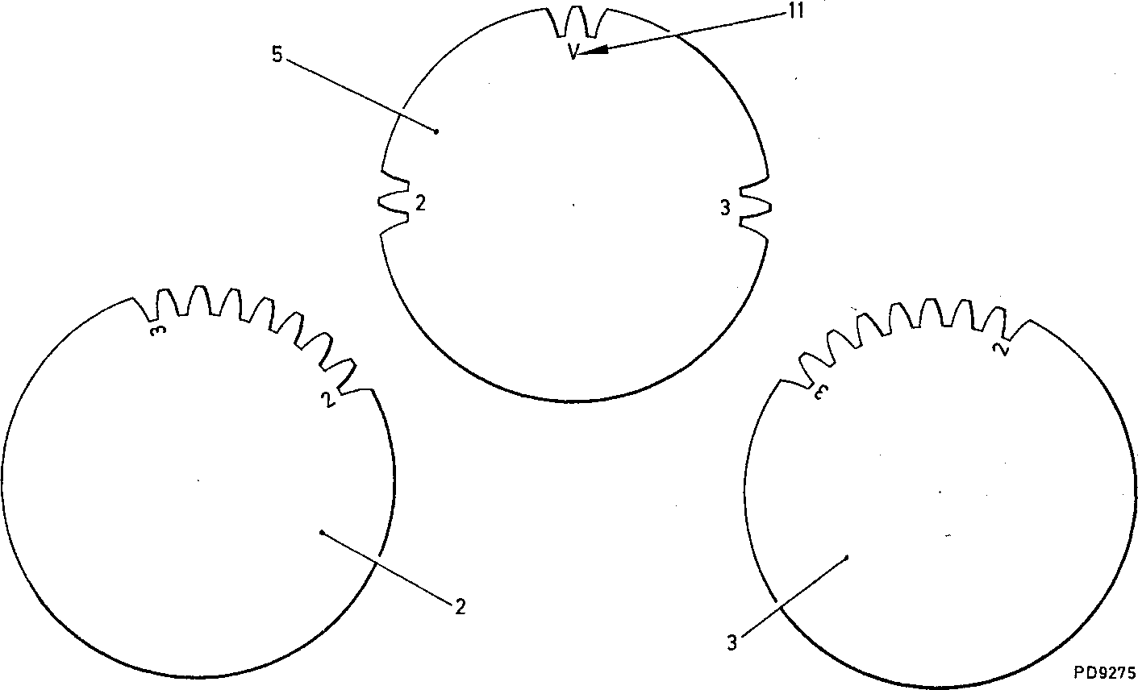Referring to Section GG, fit the cambox to the crankcase ensuring that timing marks '4' on the drive-end faces are in correct alignment.

Key to Numbers

1. Fuel pump idler, 'B' bank

5. Engine camshaft gearwheel

11. 'V' mark

1. Fuel pump idler, 'A' bank

Fig CC.2 Position of fuel pump idlers when fitting camshaft

CHAPTER 3

CHECKING AND ADJUSTING FUEL INJECTION TIMING

NOTES (1) A fuel injection cambox assembly may be removed and refitted without affecting the point of fuel injection providing the relationship between the camshaft hub and gearwheel has not been disturbed. If the relationship between the gearwheel and hub has altered, or it is suspected that the timing is incorrect, the timing may be checked as detailed below.

1. No attempt should be made to remove the delivery valve and holder from an injection pump for spill timing purposes. THIS IS A SPECIALIST OPERATION AND SHOULD ONLY BE CARRIED OUT UNDER CONTROLLED CONDITIONS IN A ROOM DEALING WITH INJECTION EQUIPMENT. A dummy injector and timing pump are provided to eliminate the necessity for spill timing. The dummy injector indicates crankshaft angle by reference to the piston position, having steps for TDC, 22°, 23°, 24°, 25°, and 30° before ’TDC*. The last step is used to determine 'VTC' position. The timing pump indicates the injection pump spill point; all injection pumps being set to this spill point during calibration.
2. Referring to Section GF, remove appropriate fuel injection pump from the cambox, ie,'A8' pump if timing 'A' bank cambox, or 'B8' pump for 'B' bank cambox.
3. Fit timing pump (7)(Fig CC.3) WITHOUT SHIMS to the vacant position and align by engaging locating pin (8) in oil transfer drilling (18). Secure the timing pump with the injection pump nuts (6), tightening the nuts just sufficiently to hold the timing pump firmly in position.
4. Referring to Section GH, remove the injector from the relevant cylinder head and insert dummy injector (4)(Fig CCA) into injector tube (6). Secure with injector clamp (2) and tighten clamp setbolt (1) 'hand tight'. Set up the dummy injector as follows
5. Rotate the crankshaft until stop collar (3) on the dummy injector is at the full extent of its upward travel.. At this point the piston will be at TDC.
6. Slacken clamp screw (14) and screw adjusting nut (12) until ends of legs (10) are flush with top of stop collar (3). and tighten clamp screw. A tolerance of ±0.005 mm (0.002 in) is allowable.

NOTE Due to the piston dwell factor at TDC, the crankshaft will have a limited amount of movement whilst creating NO PERCEPTIBLE movement of the stop collar in the dummy injector

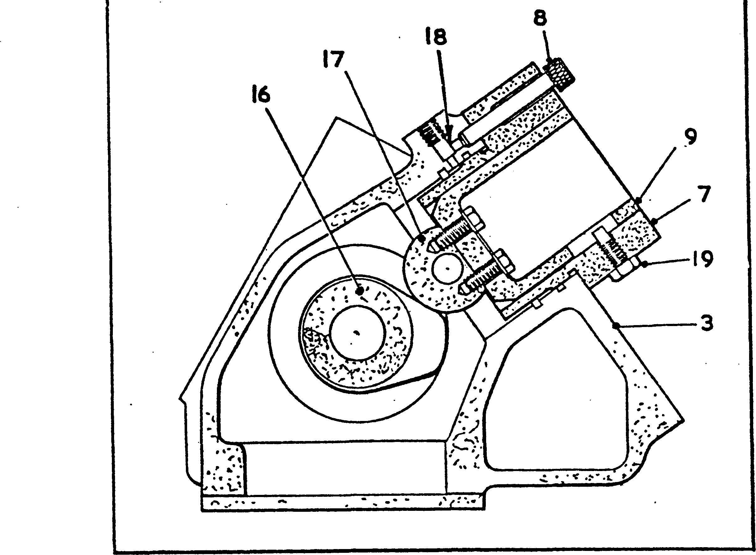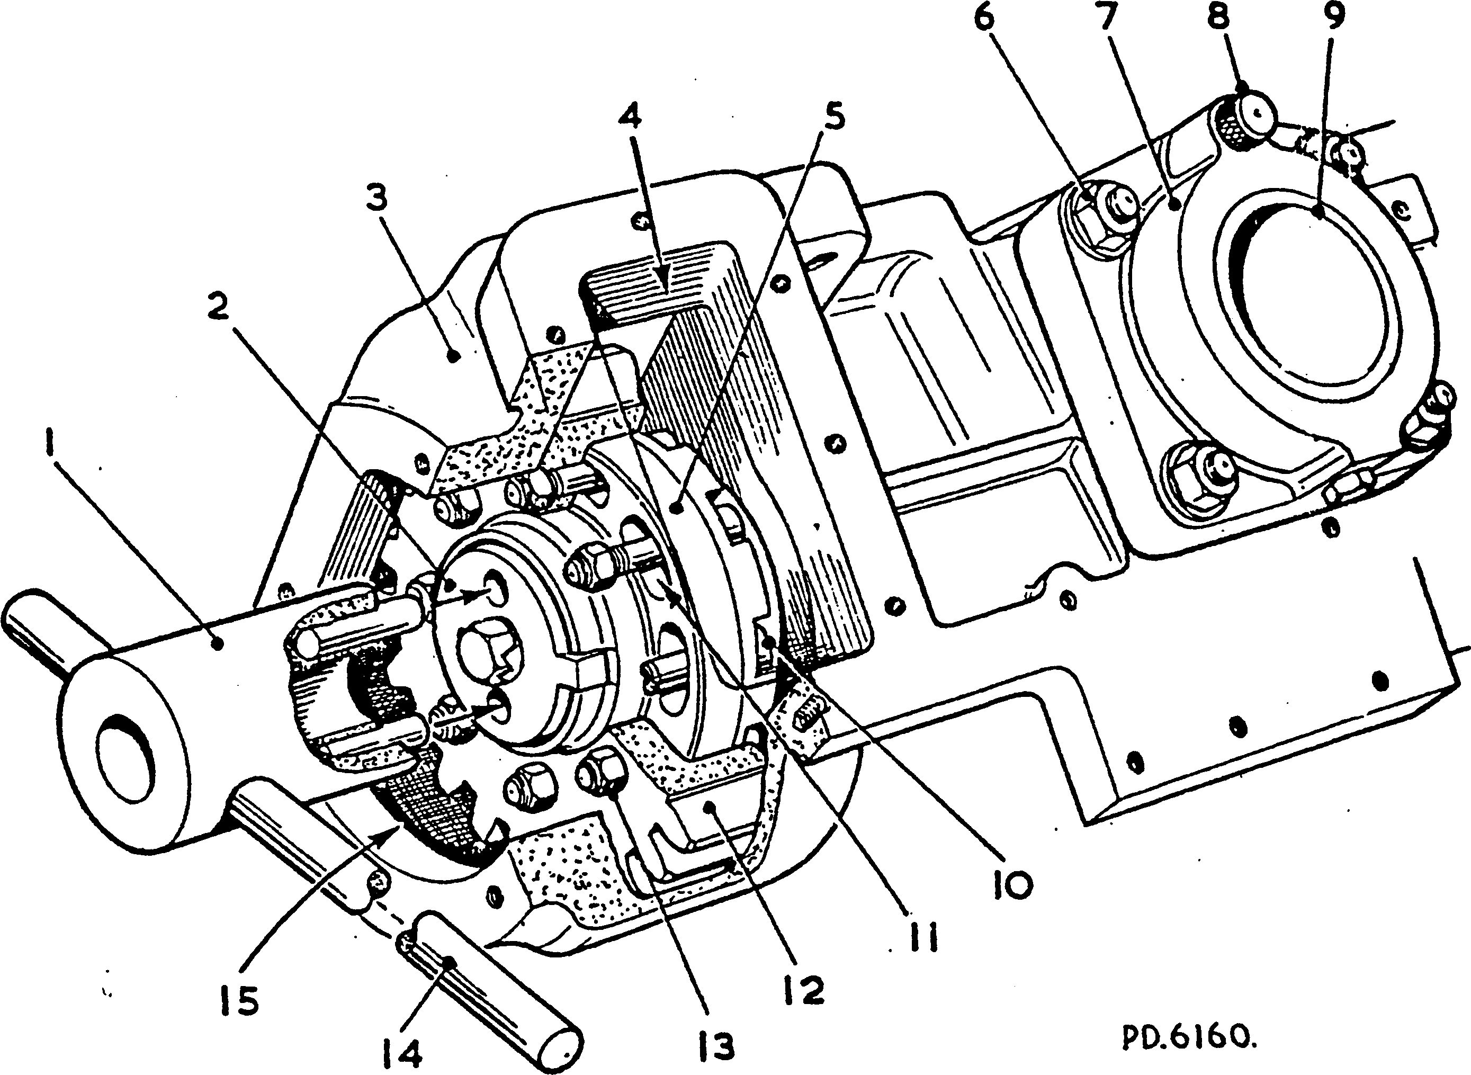

Key to Numbers

|  |  |  |  |
| --- | --- | --- | --- |
| 1. | Timing adjustor | 11. | Adjusting slots |
| 2. | Retaining plate | 12. | Camshaft gearwheel |
| 3. | Fuel pump cambox | 13. | Philidas nut |
| 4. | Cambox side aperture | 14. | Tommy bar |
| 5. | Gear hub | 15. | Cambox end aperture |
| 6. | Fuel injection pump nut | 16. | Fuel pump camshaft |
| 7. | Timing pump | 17. | Cam follower |
| 8. | Locating pin | 18. | Oil transfer drilling |
| 9. | Cam follower | 19. | Locating screw |
| 10. | Fitting bolt, gear to hub |  |  |

Fig. CC 3 Timing pump and method of camshaft adjustment

1. Rotate the crankshaft in the opposite direction of rotation approximately a quarter of a revolution and then bar slowly forward again until the stop collar is flush with the step. This ensures that all backlash in the auxiliary gear train is taken up in the direction of rotation.
2. Using a suitable straight edge, check that cam follower (9)(Fig CC.3) is flush with timing pump body (7) to within 0.005 mm (0.002 in). If the check shows that the cam follower is BELOW the body face the injection timing is RETARDED, whilst if above it is ADVANCED. To correct the injection timing it is necessary to adjust the position of the camshaft in relation to the drive gear as described below:
3. Remove cambox end cover and slacken philidas nuts (13) clamping gear wheel (12) to gear hub (5)(approximately one turn should be sufficient) and tap fitting bolts (10) back to release the grip between the hub and gear wheel.
4. Locate the timing adjuster into the retaining plate and turn the retaining plate, and therefore the camshaft, CLOCKWISE LOOKING ON THE DRIVE-END OF THE ENGINE to the limits of adjusting slots (11). The slots are not visible; resistance to movement is the only indication that this point has been reached.
5. Rotate the camshaft ANTI-CLOCKWISE by means of the timing adjuster until the cam follower is flush with the timing pump body. Tighten two diametrically opposed philidas nuts (13).
6. Repeat Paragraphs 3.4 and 3.5.
7. Tighten the philidas nuts to the torque loading quoted in Section CE.
8. Remove the dummy injector and refit the fuel injector in accordance with Section GH.
9. Remove the timing pump and refit the fuel injection pump in accordance with Section GF.

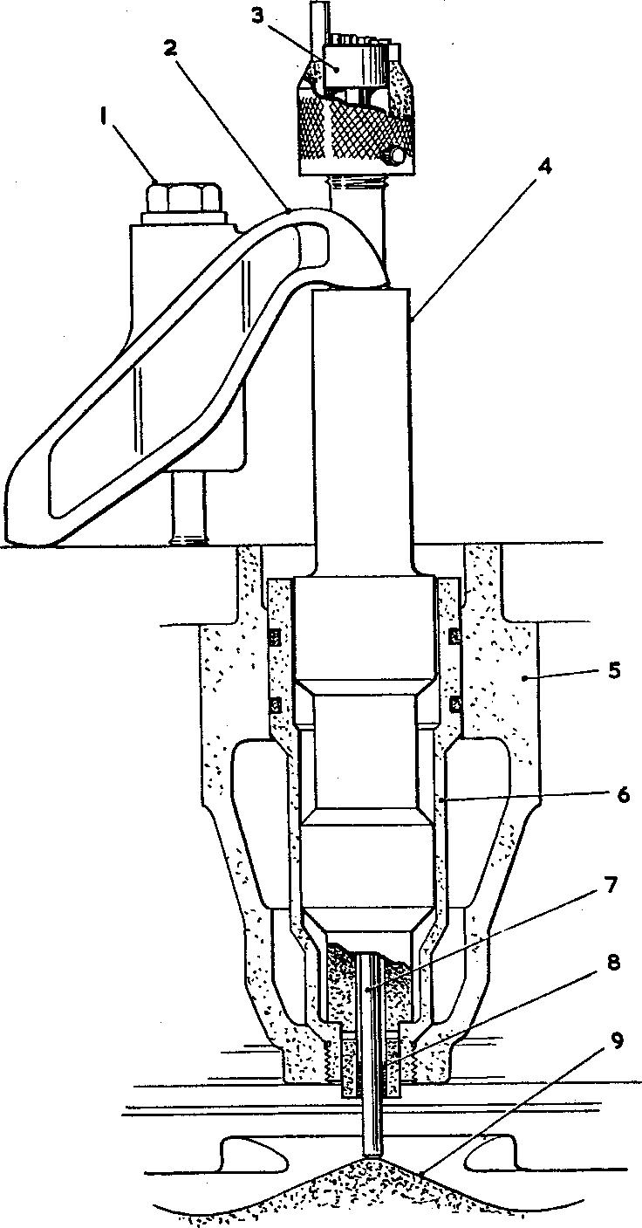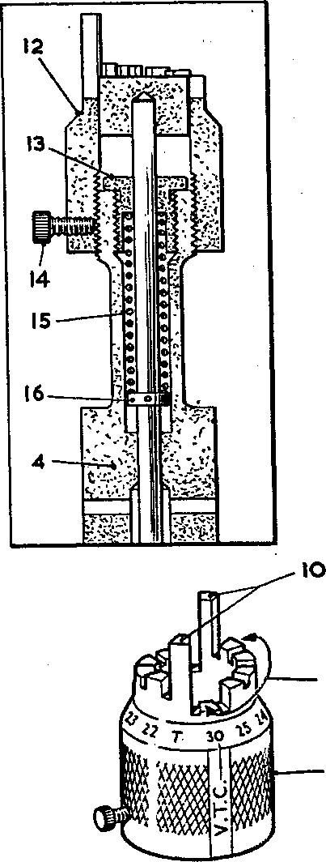

|  |  |  |  |
| --- | --- | --- | --- |
| 1. | Injector clamp bolt | 9. | Piston |
| 2. | Injector clamp | 10. | Top dead centre legs |
| 3. | Stop collar | 11. | Injection setting legs |
| 4. | Dummy injector | 12. | Adjusting nut |
| 5. | Cylinder head | 13. | Spring retaining nut |
| 6. | Injector tube | 14. | Knurled clamp screw |
| 7. | Stem | 15. | Spring |
| 8. | Bush | 16. | Spring collar |

C\ Ul -F*. U>

Key to numbers

Fig. CC4 Dummy injector

|  |  |  |
| --- | --- | --- |
| DESCRIPTION | PART NO | USE |
| Torque Wrench | OD28465 | Tightening nuts and bolts to a pre­determined loading |
| Pry Bar | OD30694P3 | Removing fuel injector from cylinder head |
| Timing adjuster | Y3J70005C | Adjusting timing of fuel pump camshaft |
| Dummy injector | Y3J70804A | Positioning the crankshaft for various timing operations |
| Timing pump | Y3J70805 | Positioning the camshaft at the correct 'spill cut-off point'. |
| Camshaft timing | Y3J70867 | Checking engine camshaft gauge timing at 'VTC' |
| Timing gauge | Y3J70866 | Positioning fuel pump idler when fitting fuel pump cambox |